Report
Of
Full-Stack RAG Application Deployment & AI Agent Automation using FastAPI, Docker, Kubernetes and Generative AI

Submitted
To
School of Computer Science and Engineering
IILM University, Greater Noida, U.P.

In partial fulfilment of the requirement of degree of
B.Tech CSE


By
Roll Number of Student: 2410031195
Name of Student: SWATI
Batch: 2026-27

2026-27

CANDIDATE'S DECLARATION

I, SWATI, do hereby declare that the internship report titled "Full-Stack RAG Application Deployment & AI Agent Automation using FastAPI, Docker, Kubernetes and Generative AI" has been completed by me to fulfil the requirement for the award of the degree of Bachelor of Technology in CSE. All the references have been quoted and I have not taken as such any material from any other source. I affirm to you that this report is my own and has not been submitted to any other institute for any degree/diploma requirement and further I shall be solely responsible for any kind of copyright violation in this regard.

Signature
Student Name: SWATI
Roll No.: 2410031195

ACKNOWLEDGEMENT

I am using this opportunity to express my gratitude to everyone who supported me throughout the Internship Program. I am thankful for their aspiring guidance, invaluably constructive criticism and friendly advice during this work. I am sincerely grateful to them for sharing their truthful and illuminating views on a number of issues related to this work.
I would like to thank the AICTE-EduSkills Virtual Internship team and my mentors at EduSkills Academy for structuring an industry-relevant learning journey in AI Deployment & Automation, and the School of Computer Science and Engineering, IILM University, Greater Noida, for facilitating this opportunity as part of my academic curriculum.
I express my gratitude to my parents for their blessings.

Signature
Student Name: SWATI
Roll No.: 2410031195

3. INTERNSHIP COMPLETION CERTIFICATE
The Internship Completion Certificate issued by EduSkills Academy, confirming successful completion of the 8-week AICTE-EduSkills Virtual Internship in AI Deployment & Automation, is reproduced below (Certificate ID: 2026-0121210835).

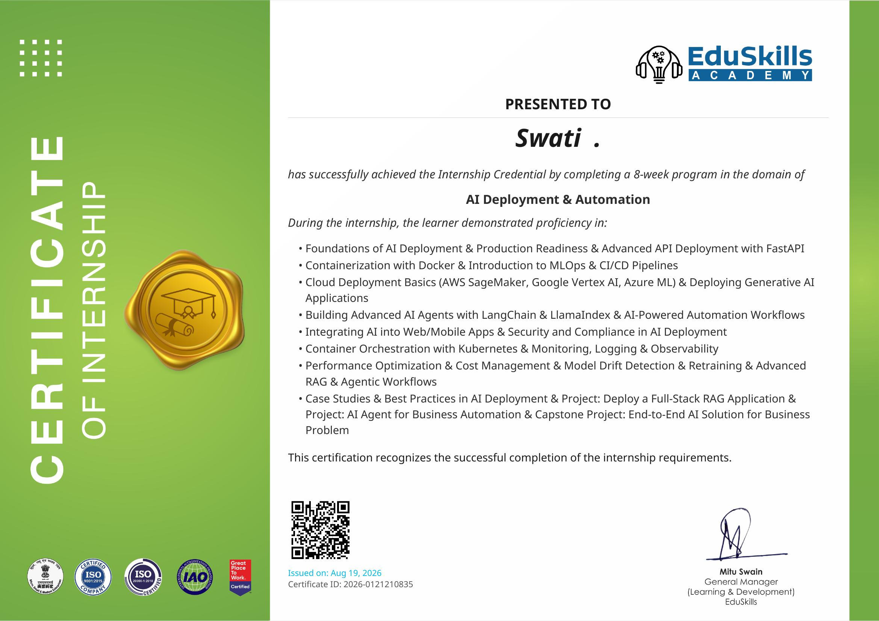

4. PROJECT DESCRIPTION
4.1 Introduction
This report presents the work undertaken during the 8-week AICTE - EduSkills Virtual Internship Program in the domain of AI Deployment & Automation, carried out between June 2026 and August 2026 under the National Internship Portal, supported by EduSkills Academy and under the patronage of AICTE. The internship followed a structured, week-wise curriculum covering the full lifecycle of taking a machine learning or generative AI model from a notebook prototype to a secure, monitored, and scalable production system. The capstone component of the internship required the design and deployment of a full-stack Retrieval-Augmented Generation (RAG) application together with an AI agent for business process automation, integrating the skills acquired across all eight modules.
Modern organizations increasingly depend on AI systems that must be reliable, secure, cost-efficient and easy to maintain once they leave the research environment. This internship was designed to build exactly those production-oriented skills - API-based model serving, containerization, cloud deployment, orchestration, observability and agentic automation - rather than only model-building skills.
4.2 Organization Profile
EduSkills Academy is an ISO 9001:2015 and ISO 20000-1:2018 certified, 'Great Place to Work' certified skilling organization that partners with the All India Council for Technical Education (AICTE) to deliver industry-aligned virtual internship programs to engineering students across India through the National Internship Portal. EduSkills works with technology partners and cloud providers to design curricula covering emerging areas such as AI/ML, cloud computing, cybersecurity and MLOps, with the stated mission of 'Nation Building Through Skills'. The internship program is directed by Mr. Bibek Ranjan, Director, EduSkills, with Ms. Mitu Swain serving as General Manager, Learning & Development.
4.3 Problem Statement
Organizations that build machine learning and generative AI models frequently struggle to move those models from experimental notebooks into dependable production services. Common challenges include: exposing models through robust and scalable APIs; packaging models and their dependencies consistently across environments; deploying and scaling services on cloud infrastructure; monitoring live models for performance issues and data/model drift; securing AI endpoints against misuse; and automating repetitive business workflows using AI agents. The problem addressed by this internship's capstone project was: how can a Retrieval-Augmented Generation application and a business-automation AI agent be designed, containerized, deployed, secured and monitored as a single, end-to-end, production-style AI solution?
4.4 Project Objectives
- To understand the complete AI deployment lifecycle, from model integration to production monitoring.
- To build and serve models through asynchronous, high-performance APIs using FastAPI.
- To containerize AI applications using Docker and manage multi-service environments.
- To implement CI/CD pipelines for automated testing and deployment of ML workflows.
- To deploy generative AI and RAG applications on cloud platforms such as AWS SageMaker, Google Vertex AI and Azure ML.
- To design and orchestrate AI agents using LangChain, LlamaIndex and LangGraph for business process automation.
- To integrate AI services into web/mobile front-ends while addressing security, privacy and bias-mitigation requirements.
- To orchestrate containerized AI services using Kubernetes and implement monitoring/observability with Prometheus and Grafana.
- To detect model drift, retrain models and optimize performance and cloud cost.
- To build a capstone full-stack RAG application and an AI agent for business automation as an integrated, end-to-end solution.
4.5 Scope of the Project
The scope of the internship project covered the design, development and deployment of a full-stack Retrieval-Augmented Generation (RAG) application with a FastAPI backend and a lightweight web front-end, supported by a business-automation AI agent. The scope included model serving, containerization, cloud deployment, container orchestration, monitoring/logging, security and compliance considerations, and drift detection with retraining strategies. Two illustrative real-world case studies - e-commerce and healthcare - were used to contextualize the applied AI projects during the final week. The scope was limited to a demonstrative/virtual production environment as provided by the internship platform and did not extend to deployment on a live commercial production system.
4.6 Technologies and Tools Used
- Programming & API: Python, FastAPI, asynchronous programming (async/await).
- Containerization & Orchestration: Docker, Docker Compose, Kubernetes (Pods, Deployments, Services).
- CI/CD & MLOps: CI/CD pipelines for ML workflows, MLOps principles and terminology.
- Cloud Platforms: Amazon SageMaker, Google Vertex AI, Azure Machine Learning.
- Generative AI & Agents: LLM serving, vLLM, model quantization, LangChain, LlamaIndex, LangGraph.
- Front-End / Integration: Streamlit, Gradio.
- Monitoring & Observability: Prometheus, Grafana.
- Drift Detection & Retraining: Evidently AI, vector databases for RAG.
- Security & Compliance: AI system security, threat handling, privacy and bias-mitigation strategies.
4.7 System Architecture
The end-to-end architecture consisted of the following layers: (1) a data/knowledge layer using a vector database to store embeddings for retrieval; (2) a model-serving layer where the language model and retrieval logic were wrapped inside a FastAPI application exposing REST endpoints; (3) a containerization layer where the FastAPI service and its dependencies were packaged into Docker images; (4) an orchestration layer using Kubernetes Pods, Deployments and Services to manage scaling and availability of the containerized services; (5) a cloud deployment layer using platforms such as AWS SageMaker, Google Vertex AI or Azure ML to host the models and endpoints; (6) an agent layer, built with LangChain, LlamaIndex and LangGraph, that orchestrated multi-step business-automation workflows on top of the RAG service; (7) a front-end/integration layer using Streamlit/Gradio to expose the application to end users; and (8) a monitoring and observability layer using Prometheus and Grafana, supported by Evidently AI for model drift detection, feeding back into a retraining pipeline.
4.8 Methodology
The internship followed a structured, week-wise methodology as prescribed by EduSkills Academy:
- Week 1: AI Deployment Foundations & FastAPI Model Serving - AI lifecycle, production readiness, MLOps terminology, environment setup, advanced API deployment using FastAPI with model integration and asynchronous operations.
- Week 2: Containerization & CI/CD for MLOps - Docker architecture, Dockerfiles, networking, volumes, MLOps principles, and CI/CD pipelines for ML workflows.
- Week 3: Cloud AI Deployment & Generative AI Serving - deployment on AWS SageMaker, Google Vertex AI and Azure ML; deploying generative AI applications; LLM challenges, vLLM serving and model quantization.
- Week 4: AI Agents & Automation Workflows - building advanced AI agents with LangChain and LlamaIndex, agent orchestration with LangGraph, and AI-powered hyper-automation workflows.
- Week 5: AI Integration, Security & Compliance - integrating AI into web/mobile apps using Streamlit and Gradio, securing AI systems, privacy and bias-mitigation strategies.
- Week 6: Kubernetes & Observability in Production AI - container orchestration with Pods, Deployments and Services; monitoring and logging with Prometheus and Grafana.
- Week 7: Performance Optimization, Drift & Advanced RAG - model performance tuning, cloud cost optimization, drift detection with Evidently AI, retraining strategies, advanced RAG architectures and vector database integrations.
- Week 8: Applied AI Projects & Capstone Projects - real-world case studies (e-commerce and healthcare), full-stack RAG application development (FastAPI backend + front-end), an AI agent for business automation, and a complete end-to-end production AI solution covering model development, API deployment, monitoring and scaling.
Progress was assessed through weekly assessments, submission of project documentation/assignments for selected modules, and a Final Assessment Test in the last week, with the overall grade based on cumulative performance across all three components.
4.9 Expected Outcomes
- A working, containerized full-stack RAG application capable of answering domain queries using retrieved context.
- An AI agent workflow demonstrating automation of a representative business process.
- Practical, hands-on familiarity with deploying and scaling AI services on Kubernetes and major cloud platforms.
- Ability to monitor deployed models for performance degradation and drift, and to plan retraining accordingly.
- Awareness of security, privacy and bias-mitigation practices required for responsible AI deployment.
- Enhanced employability through demonstrable, production-oriented AI deployment skills, recognized via the AICTE-EduSkills Internship Credential.
4.10 Certificates of Completion and Other Communication/Mail Proof
The following documents are attached in support of this report:
- Internship Offer Letter (Ref No. C17Y2026M081511437), issued to Swati, B.Tech (Computer Science and Engineering), IILM University, Greater Noida, for the AI Deployment & Automation internship domain, duration June 2026 - August 2026.
- Internship Completion Certificate issued by EduSkills Academy (Certificate ID: 2026-0121210835), issued on August 19, 2026, confirming successful completion of the 8-week internship.
(Scanned copies of the above documents, and any additional email communication received from EduSkills/AICTE regarding enrolment or completion, should be physically attached as an annexure to this page.)

5. BIBLIOGRAPHY / REFERENCES
1. EduSkills Academy, "Internship Offer Letter," Ref No. C17Y2026M081511437, EduSkills Foundation, 2026.
2. EduSkills Academy, "Certificate of Internship - AI Deployment & Automation," Certificate ID: 2026-0121210835, Issued Aug 19, 2026.
3. FastAPI Documentation, https://fastapi.tiangolo.com/
4. Docker Documentation, https://docs.docker.com/
5. Kubernetes Documentation, https://kubernetes.io/docs/
6. LangChain Documentation, https://python.langchain.com/
7. LlamaIndex Documentation, https://docs.llamaindex.ai/
8. Amazon SageMaker Developer Guide, Amazon Web Services, https://docs.aws.amazon.com/sagemaker/
9. Google Vertex AI Documentation, Google Cloud, https://cloud.google.com/vertex-ai/docs
10. Azure Machine Learning Documentation, Microsoft, https://learn.microsoft.com/azure/machine-learning/
11. Prometheus Documentation, https://prometheus.io/docs/
12. Grafana Documentation, https://grafana.com/docs/
13. Evidently AI Documentation, https://docs.evidentlyai.com/
14. AICTE - National Internship Portal, https://internship.aicte-india.org/

